C. The Football Season
time limit per test
1 second
memory limit per test
256 megabytes
input
standard input
output
standard output
The football season has just ended in Berland. According to the rules of Berland football, each match is played between two teams. The result of each match is either a draw, or a victory of one of the playing teams. If a team wins the match, it gets ww points, and the opposing team gets 00 points. If the game results in a draw, both teams get dd points.
The manager of the Berland capital team wants to summarize the results of the season, but, unfortunately, all information about the results of each match is lost. The manager only knows that the team has played nn games and got pp points for them.
You have to determine three integers xx, yy and zz — the number of wins, draws and loses of the team. If there are multiple answers, print any of them. If there is no suitable triple (x,y,z)(x,y,z), report about it.
Input
The first line contains four integers nn, pp, ww and dd (1≤n≤1012,0≤p≤1017,1≤d<w≤105)(1≤n≤1012,0≤p≤1017,1≤d<w≤105) — the number of games, the number of points the team got, the number of points awarded for winning a match, and the number of points awarded for a draw, respectively. Note that w>dw>d, so the number of points awarded for winning is strictly greater than the number of points awarded for draw.
Output
If there is no answer, print −1−1.
Otherwise print three non-negative integers xx, yy and zz — the number of wins, draws and losses of the team. If there are multiple possible triples (x,y,z)(x,y,z), print any of them. The numbers should meet the following conditions:
- x⋅w+y⋅d=px⋅w+y⋅d=p,
- x+y+z=nx+y+z=n.
Examples
input
Copy
30 60 3 1
output
Copy
17 9 4
input
Copy
10 51 5 4
output
Copy
-1
input
Copy
20 0 15 5
output
Copy
0 0 20
Note
One of the possible answers in the first example — 1717 wins, 99 draws and 44 losses. Then the team got 17⋅3+9⋅1=6017⋅3+9⋅1=60 points in 17+9+4=3017+9+4=30 games.
In the second example the maximum possible score is 10⋅5=5010⋅5=50. Since p=51p=51, there is no answer.
In the third example the team got 00 points, so all 2020 games were lost.

就是求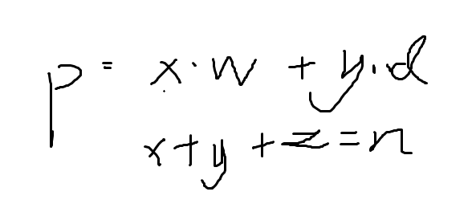
x.y.z;
然后当y大于w的时候。。
就变成了 x*w+(w+k)*d 然后就是 w*(x+d)+k*d.
所以只要找y从0到w就OK了

#include<bits/stdc++.h>
#define ll long long
using namespace std;
int main()
{
ll n,p,d,w;
scanf("%lld %lld %lld %lld",&n,&p,&w,&d);
ll x=0;
ll y=0;
while(y<=w)
{
x=(p-y*d)/w;
if((p-y*d)%w==0)
{
if(n-x-y>=0&&x>=0)
{
printf("%lld %lld %lld",x,y,n-x-y);
break;
}
}
y++;
}
if(y>w)
printf("-1");
return 0;
}

